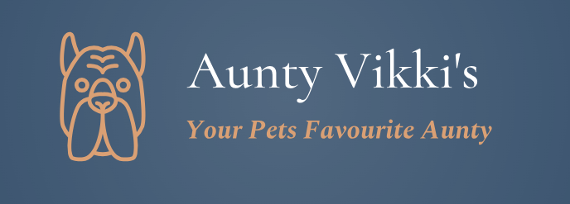

Boarding Contract
Boarding Dates: From………………….. To………………….
Name of Dog: …………………………………………………………………………………………………………………………………..
Breed of Dog:……………………………………………………………………………………………………………………………………
Sex of dog: Male / Female
Colour of Dog:………………………………………………………………………………………………………………………………….
Microchip Number:…………………………………………………………………………………………………………………………..
Name of owner:………………………………………………………………………………………………………………………………..
Address of owner:………………………………………………………………………………………………………………………………
Phone number of owner: ………………………………………………………………………………………………………………….
Email address of owner:…………………………………………………………………………………………………………………….
Name and contact number of emergency contact:…………………………………………………………………………….
Email address of emergency contact:………………………………………………………………………………………………….
Name and address of dogs veterianrian:…………………………………………………………………………………………….
In the event of an out of hours emergency are you happy for your dog to receive emergency veterinary treatment from Evans Veterinary Parctice, Mold, Flintshire: Yes / No
Proof of up to date vaccinations including Kennel Cough:…………………………………………………………………..
Does your dog have any health issues: Yes / No
If yes, please provide details:…………………………………………………………………………………………………………..
………………………………………………………………………………………………………………………………………………………..
Is your pet Spayed / Neutered: Yes / No

Does your dog need any madication administering during their stay? Yes / No
If yes, please provide details:…………………………………………………………………………………………………………..
…………………………………………………………………………………………………………………………………………………………
Does your pet have any allergies:………………………………………………………………………………………………………
If yes, please provide details:…………………………………………………………………………………………………………….
Feeding requirements & Treats:…………………………………………………………………………………………………………
Has your dog ever shown aggression towards other dogs? Yes / No
If yes, please provide additional information:…………………………………………………………………………………….
…………………………………………………………………………………………………………………………………………………………..
…………………………………………………………………………………………………………………………………………………………..
Has your dog ever shown aggression towards humans? Yes / No
If yes, please provide additional information:……………………………………………………………………………………..
……………………………………………………………………………………………………………………………………………………………
…………………………………………………………………………………………………………………………………………………………….
Does your dog have any fears/dislikes that we need to know about? Yes / No
If yes, please give details:…………………………………………………………………………………………………………………….
……………………………………………………………………………………………………………………………………………………………
Does your dog have any behavioural issues we need to know about eg resource guarding, reactivity, separation anxiety, excessive barking etc? Yes / No
If yes, please give details:…………………………………………………………………………………………………………………….
…………………………………………………………………………………………………………………………………………………………….
Do you give permission for photographs of your pet to be shared on social media? Yes / No

The information I have shared today is a true and accurate representation of my pet. Should this change prior to their boarding date, I will ensure this information is passed to Aunty Vikki’s Pet Services immediately.
In the event of an emergency, Aunty Vikki’s Pet Services will attempt to contact you on the emergency contact details provided. If they are unable to reach you or your designated emergency contact your dog will be taken immediately to your specified veterinary practice or Evans Veterinary Practice if agreed above. Aunty Vikki’s Pet Services will continue to try and contact you to provide an update however, if this is not possible, we will proceed with any necessary treatment for your pet. The cost of all veterinary treatment will be incurred by yourselves and you agree to these terms.
The best possible care will be given to your pet whilst boarding with us, but there may be times of unpredictability. In the unlikely event your pet escapes, is injured or passes away, Aunty Vikki’s Pet Services will not be heald liable for this.
Any services cancelled with 7 days prior notice will be refunded. Cancellation with less than 7 days notice will make your 50% deposit non-refundable.
A 50% deposit will be payable at the time of your booking in order to hold those dates for your pet’s stay. The remaining balance will be payable upon delivery of your pet to Aunty Vikki’s Pet Services.
I understand and agree to all the information written and printed on this contarct and wish to proceed with Aunty Vikki’s Pet Services for the care of my pet.

Pet Owners Signature…………………………..
Date……………………………………………………..

Aunty Vikki’s Pet Services Ltd
28 Glan Y Don
Greenfield
CH8 7HQ
Signed……………………………………………………
Date………………………………………………………

